Managing Users, Groups, and Sudo Privileges? SSH Security & Key-Based Authentication? Understanding SELinux & AppArmor

Tasks

1. Create a new user called streamer and a group called musicfans on your Linux system, then add streamer to the musicfans group. Verify the group membership using the id command.

ANS:

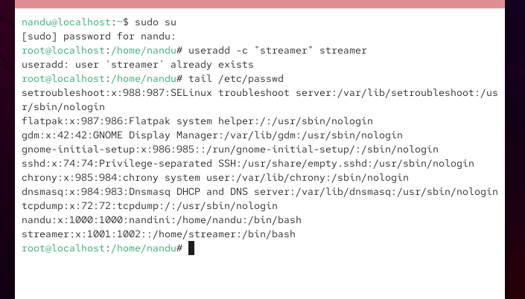

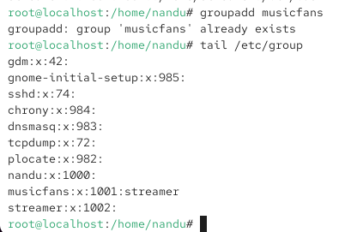

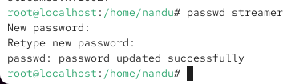

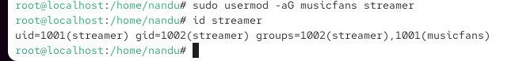

2. Give your current user sudo privileges by editing the /etc/sudoers file using visudo. Test by running a
command that requires sudo, such as updating the package list.

ANS:

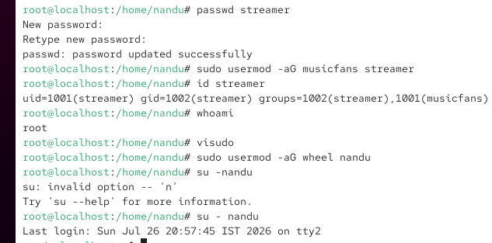

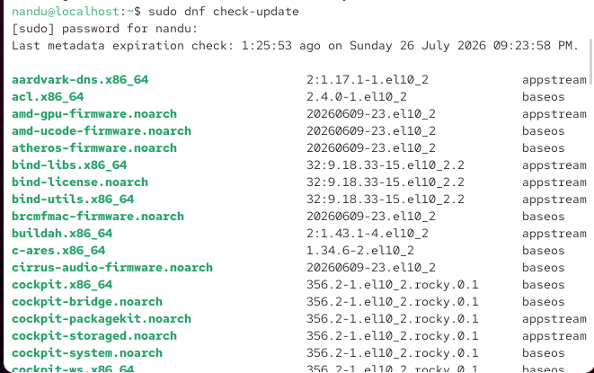

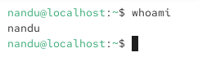

3. Set up SSH key-based authentication: generate an SSH key pair using ssh-keygen, then copy your public key to a remote Linux server (or a local VM) using ssh-copy-id. Disable password authentication for SSH in /etc/ssh/sshd_config and restart the SSH service. Look for the PasswordAuthentication setting in the SSH config file.

ANS:

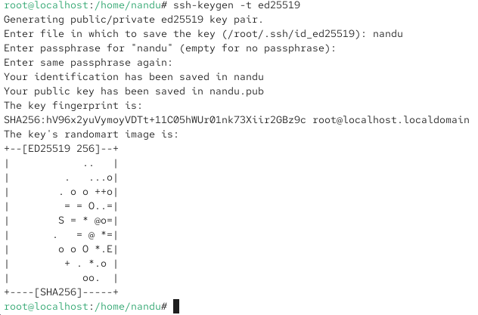

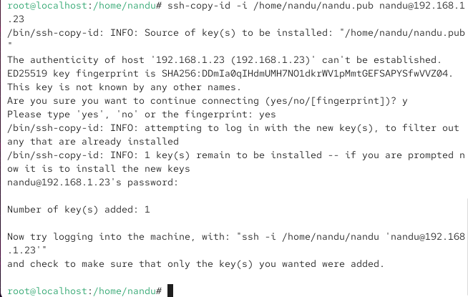

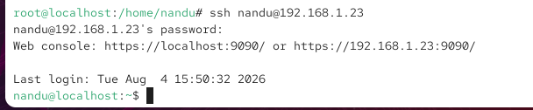

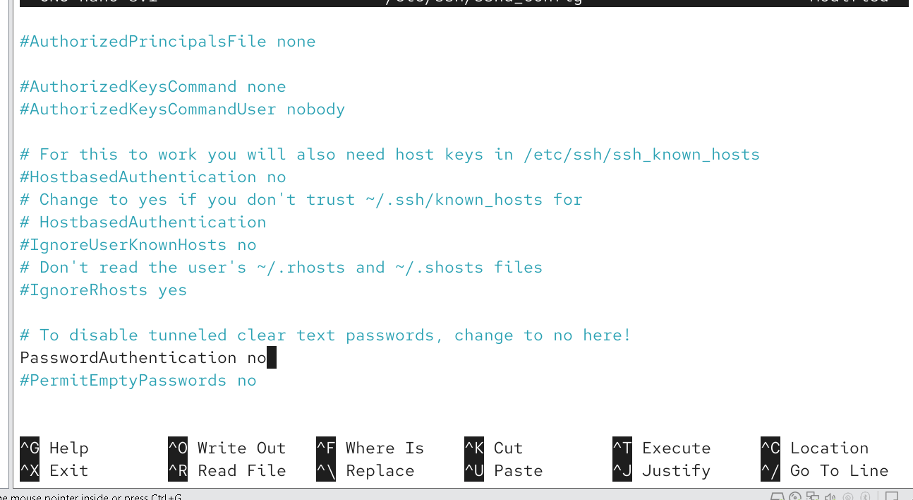

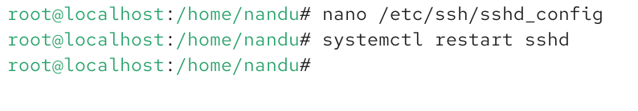

4. Check if SELinux or AppArmor is enabled on your system. If SELinux is active, use the getenforce command to display its current mode, and switch it to permissive mode. If AppArmor is active, list all enforced profiles using sudo apparmor_status.

ANS:

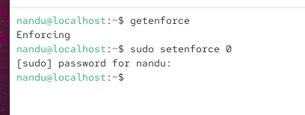

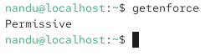

5. Use ChatGPT to explain the difference between SELinux and AppArmor in one paragraph, then write a summary in your own words and mention one real-world app (like Zomato or Paytm) that would benefit from these security modules.

ANS:

Explanation (One Paragraph)
SELinux (Security-Enhanced Linux) and AppArmor are Linux security modules that provide Mandatory Access Control (MAC) to improve system security by restricting what applications and users can do, even if they are compromised. SELinux, developed by the NSA, uses a label-based security model where files, processes, and resources are assigned security contexts, making it highly secure and suitable for enterprise environments such as Red Hat Enterprise Linux. AppArmor, developed by Canonical, uses path-based security profiles that are generally easier to create, understand, and manage, making it popular on Ubuntu systems. While SELinux offers more granular and flexible security controls, AppArmor is simpler to configure and maintain for many common use cases.

Summary (In My Own Words)
SELinux and AppArmor both help protect Linux systems by limiting what programs are allowed to access. SELinux provides stronger and more detailed security but is more complex to configure, whereas AppArmor is easier to use and manage because it relies on file paths instead of security labels. The choice between them depends on the operating system and the level of security required.

Real-World Example
Paytm would benefit from security modules like SELinux or AppArmor because they help protect sensitive customer information, payment transactions, and backend services. Even if an application is compromised, these security modules can prevent attackers from accessing critical system files or other services, reducing the risk of data breaches and financial fraud.

